Add Constant -001 Form User Input

**Solution :**

in

add 96

out

hlt

*96

dat -001

**Output :**

Add Two Constant

**Solution :**

LDA 96

ADD 97

out

hlt

*96

dat 005

*97

dat 005

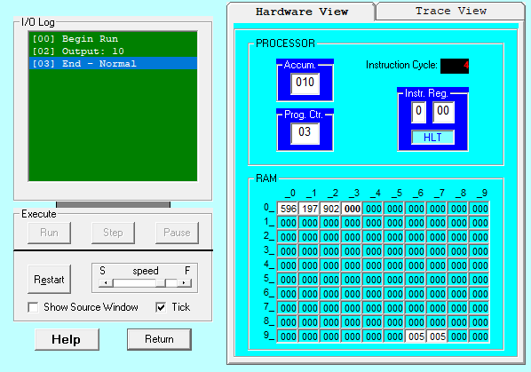**Output :**

Add Two User Input

**Solution :**

in

STO 96

in

STO 97

add 96

out

hlt

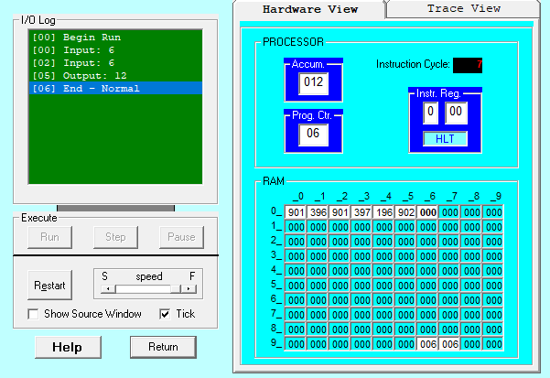**Output :**

Subtract Constant 5 From User Input

**Solution :**

in

SUB 96

out

hlt

*96

dat 005

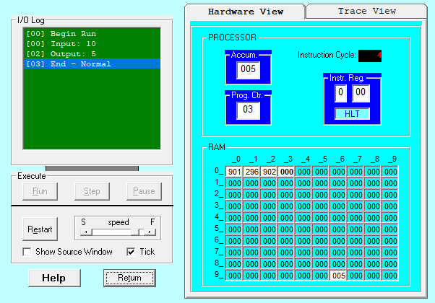**Output :**

